Query all columns for a city in CITY with the ID 1661.

Input Format

The CITY table is described as follows:

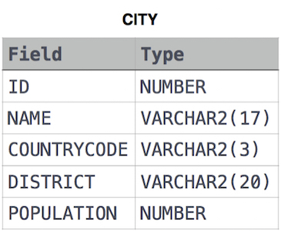

Solution :

SELECT \*

FROM CITY

WHERE ID=1661;